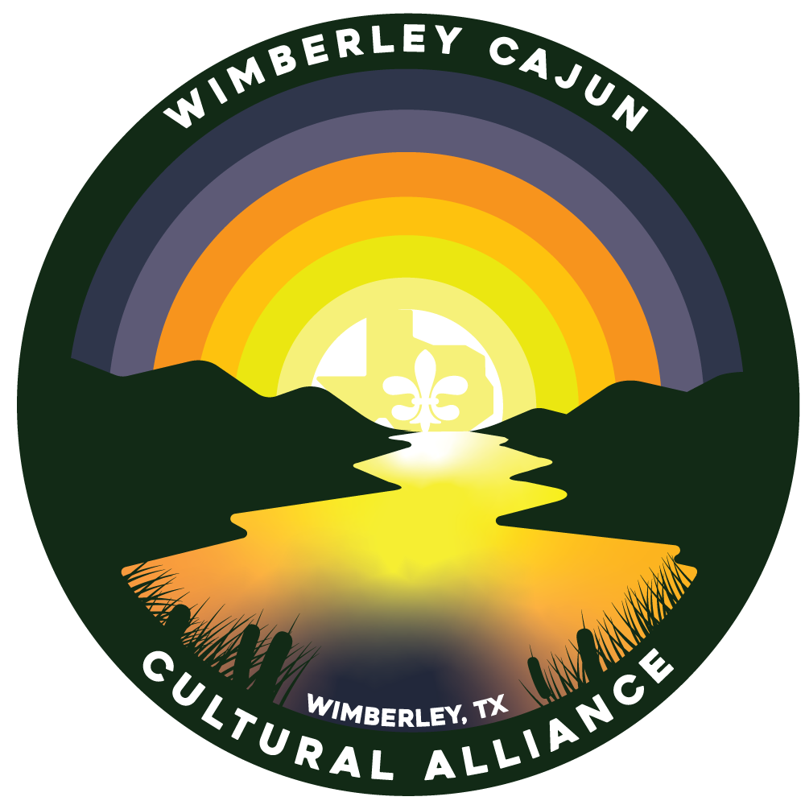
2022 WCCA GumboFest Cookoff Rules and Entry Form
GUMBO MUST:
- Be cooked on site the day of the cook-off.
- Be at least three (3) gallons when finished.
- Be prepared from scratch, including roux (no commercial gumbo mixes) and all ingredients must be added on site and in raw form but may be chopped and cut ahead of time. All ingredients must be inspected upon check-in by the Gumbo Coordinator. The Gumbo Coordinator will continue to inspect each booth until the Judging is complete. Your team may begin cooking after the Head Cook has reported to the Gumbo Coordinator and has received a judging cup. The Head Cook is responsible for safeguarding the judging cup and matching number ticket. A matching number ticket must be presented to claim winning Gumbo. (Only one judging cup can be turned in per team)
- Be prepared in as sanitary a manner as possible.
1). You must be willing to taste your own gumbo.
2). Cooking conditions are subject to inspection.
- Be cooked in the open (no motorhomes, closed tents, etc.)
- Be ready for Judging and tasting at 1 pm.
GENERAL RULES:
- Texas Alcohol Laws will be enforced; everyone must be 21 years of age to consume alcoholic beverages. No outside alcohol permitted.
- The Head Cook will be responsible for ensuring that the booth area is kept clean, both during and after the event. Teams are responsible for their own garbage.
- Failure to follow these rules will be grounds for disqualification. The Gumbo Coordinator, Representatives of WCCA reserves the right to make additional regulations as situations warrant. Decisions of this committee and Judges are final.
JUDGING CRITERIA:
1. AROMA – should smell appetizing
2. CONSISTENCY – should be smooth combination meat/seafood or roux
3. COLOR – should look appetizing
4. TASTE – should taste good, pleasing to the palate
5. AFTERTASTE – should leave a pleasant taste after swallowing

WHAT TO BRING:
Propane stove and fuel, fire extinguisher, cooking pots, serving utensils, tent, ingredients, and decorations. No ground fires allowed. No electricity will be provided. Food permits are not required however, teams should follow all cleaning and sanitary rules provided by the Hays County Public Health and Environmental Services Department: http://www.co.hays.tx.us/local-health-department.aspx
WHAT WILL BE PROVIDED:
Each team will receive 1 space not less than 10x10, (4) four team passes
WHEN:
April 23, 2022. Setup begins at 8 AM (early setup available the night before). Head cook’s meeting will be held at 9 AM. Meeting attendance isn’t required but is recommended. Doors open to the public at 12 pm. Gumbo entries must be turned in at 1 pm. Winners will be announced at 5 pm.
WHERE:
Cypress Falls, 50 Marina Circle, Wimberley, TX 78676.
Best Decorated Booth… FREE ENTRY FEE
There is a $50 entry fee per team. All entries must be received by April 15th, 2022. Team member names do not need to be given until time of check-in.

TEAM NAME: __________________________ TEAM CAPTAIN: ___________________

BILLING ADDRESS: ___________________ TEAM MEMBER: ___________________

CITY/STATE/ZIP: _______________________ TEAM MEMBER: ___________________

HOME OR CELL PHONE: _______________ TEAM MEMBER: ___________________

EMAIL: ________________________________

ENTRY FEE AND COMPLETED FORM MUST BE RETURNED BY APRIL 15TH, 2022 TO 7425 FM 2325 WIMBERLEY, TX 78676.
THE ENTRY FEE FOR THIS EVENT IS $50 AND IS PAYABLE BY CASH, CHECK, MONEY ORDER PAYABLE TO “WCCA.”, or VENMO.
FOR MORE INFORMATION OR ANY QUESTIONS E-MAIL: WIMBOGUMBOCOOKOFF@GMAIL.COM
I HAVE READ THE RULES AND REGULATIONS PROVIDED, AND I AGREE TO ABIDE BY ALL GUIDELINES SET FORTH BY THE WCCA GUMBO COOK-OFF MARDI GRAS COMMITTEE. FAILURE TO ABIDE BY THE RULES WILL SUBJECT MY TEAM TO DISQUALIFICATION.

Signature: ______________________________________ Date: ____________

